NIRMAYEE S. KADAM PRN-25070521134 SEC-C1
EXPERIMENT 5.1.1- LEAP YEAR CHECKER

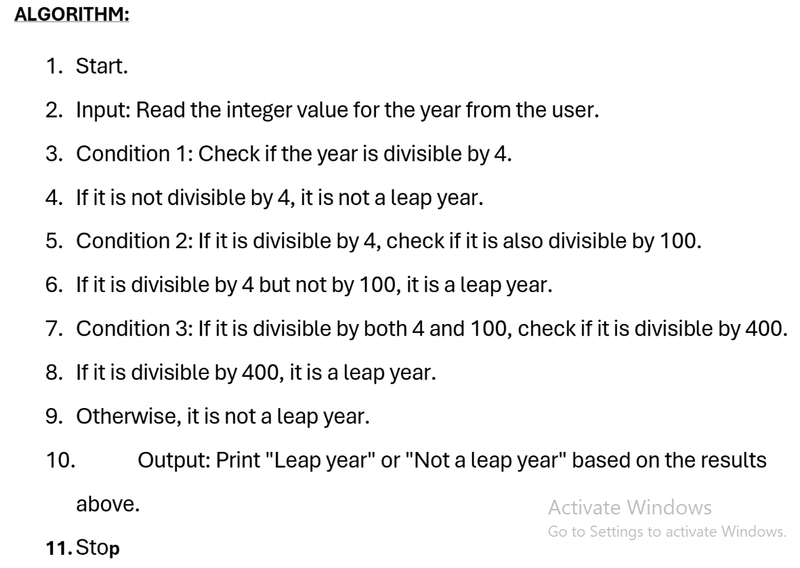
FLOWCHART:
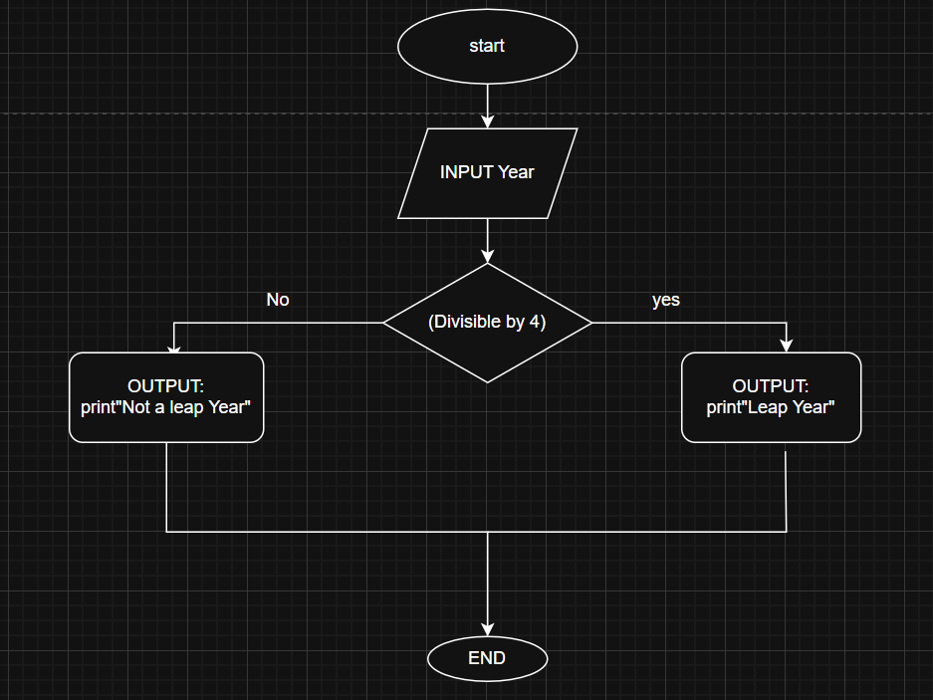

CODE:
